Editorial Revisions to be carried out in the website Content

HOMEPAGE

- We may use the interim emblem developed (enclosed) for the website
- Italicise all Sanskrit verses/words that are rendered in Roman script throughout the site
- ‘Marga Darshak’ must be spelt without diacritical marks everywhere
- Replace text:
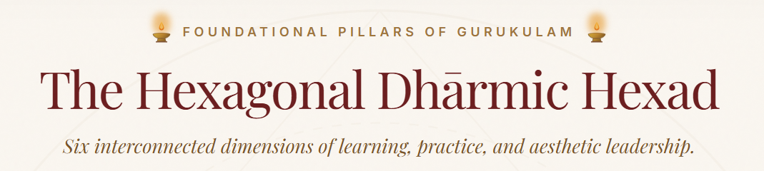

With the following text:

THE GURUKULAM'S FOUNDATIONS
The Six Pillars
Six interconnected dimensions of learning, practice, transmission, aesthetic experience, and responsibility.

- Replace text
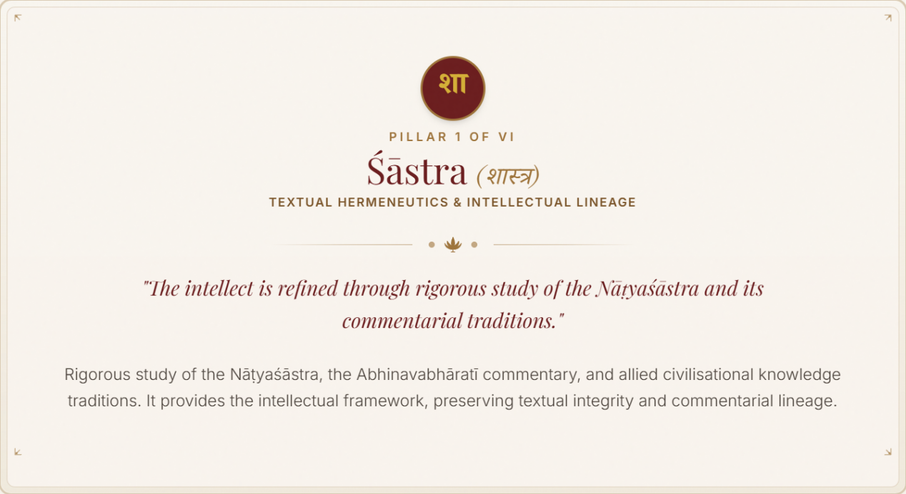

With the following text:

Śāstra (शास्त्र)

TEXTUAL STUDY & COMMENTARIAL TRADITION
Śāstra gives form to inquiry; disciplined study opens the way to understanding.
Study of the Nāṭyaśāstra, the Abhinavabhāratī and the traditions of commentary through which their knowledge has been received, interpreted, and transmitted.
- Replace text
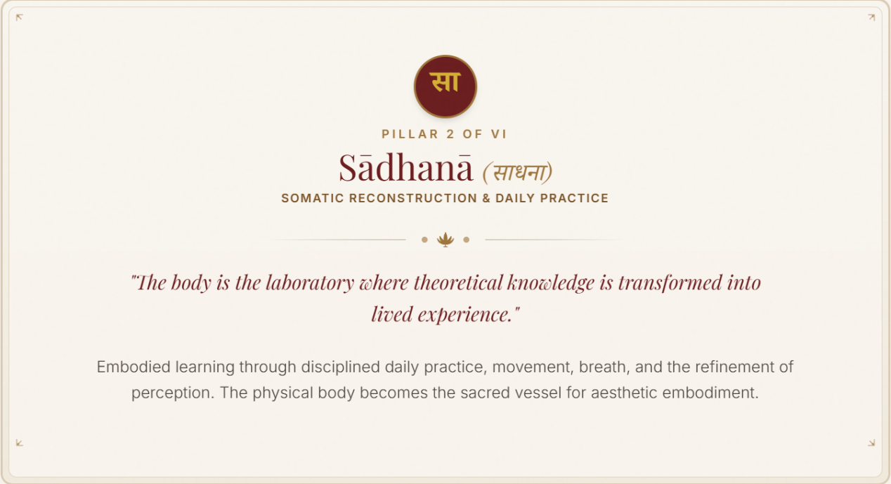

With the following text:

Sādhanā (साधना)

EMBODIED PRACTICE & INNER REFINEMENT
Śāstra becomes knowledge through practice; practice becomes sādhanā through disciplined attention.
Sādhanā is the disciplined cultivation of body, breath, attention, perception, and conduct. Through sustained practice, what is received through śāstra moves from intellectual understanding towards embodied experience and inner refinement.

- Replace text
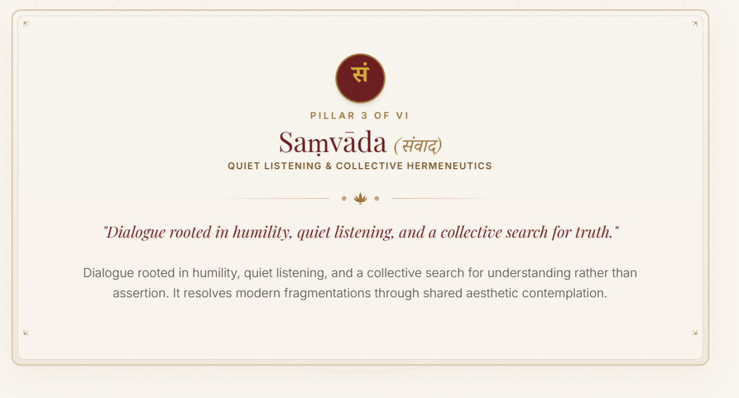

With the following text:

Saṃvāda (संवाद)

ATTENTIVE LISTENING & SHARED INQUIRY
Understanding deepens through attentive listening, questioning, and encounter.
A space for listening, reflection, questioning, and dialogue, where knowledge is deepened through encounter and shared inquiry rather than assertion.

- Replace text
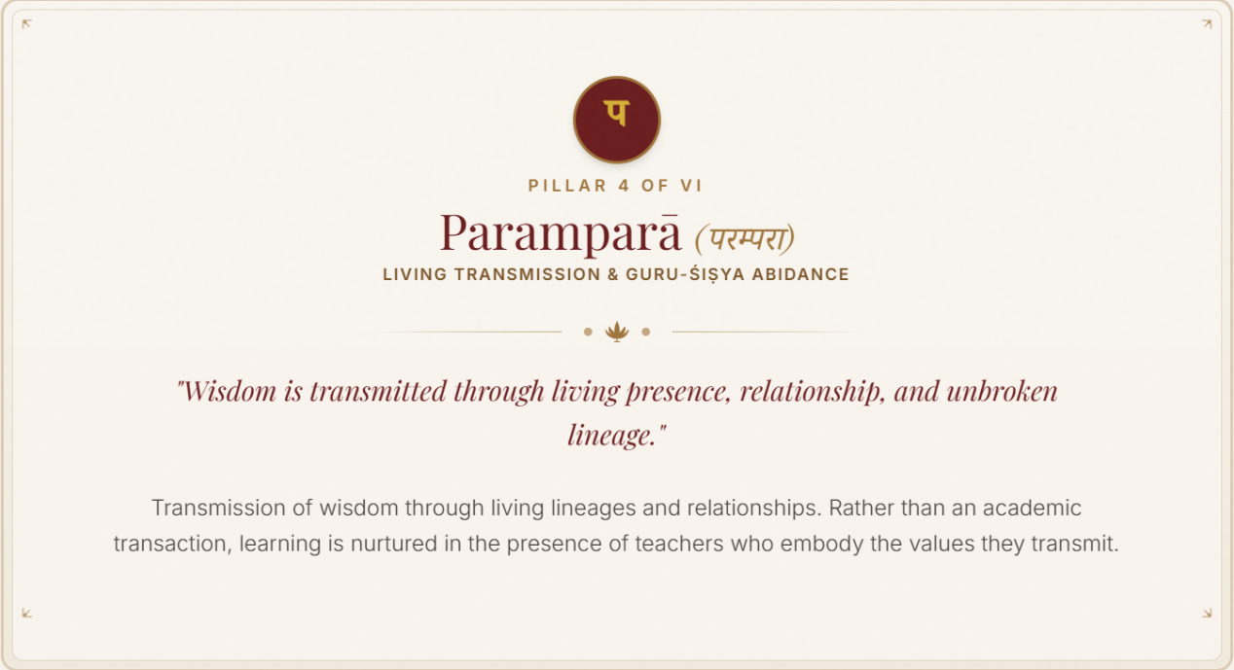
With the following text:

Paramparā (परम्परा)
LIVING TRANSMISSION & GURU–ŚIṢYA PARAMPARĀ
“Wisdom is transmitted through living presence, relationship, and lineage.”
Wisdom is transmitted through living lineages and relationships. Rather than mere academic instruction, learning is nurtured through the presence of teachers who embody the values they transmit.

- Replace text
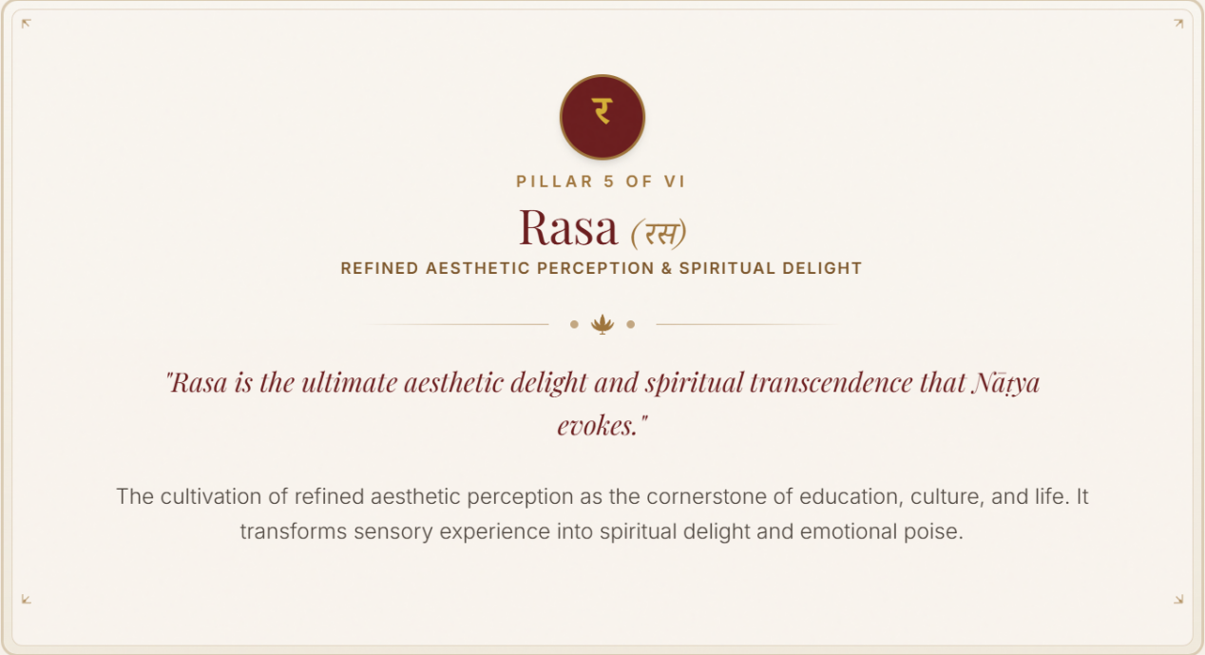
With the following text:
Rasa (रस)
REFINED AESTHETIC PERCEPTION & AESTHETIC DELIGHT
“Rasa is the aesthetic relish that Nāṭya awakens through refined perception.”
The cultivation of refined aesthetic perception as a cornerstone of education, culture, and life. Through Nāṭya, sensory experience is refined into aesthetic relish, deepening perception, sensitivity, and poise.

- Replace text
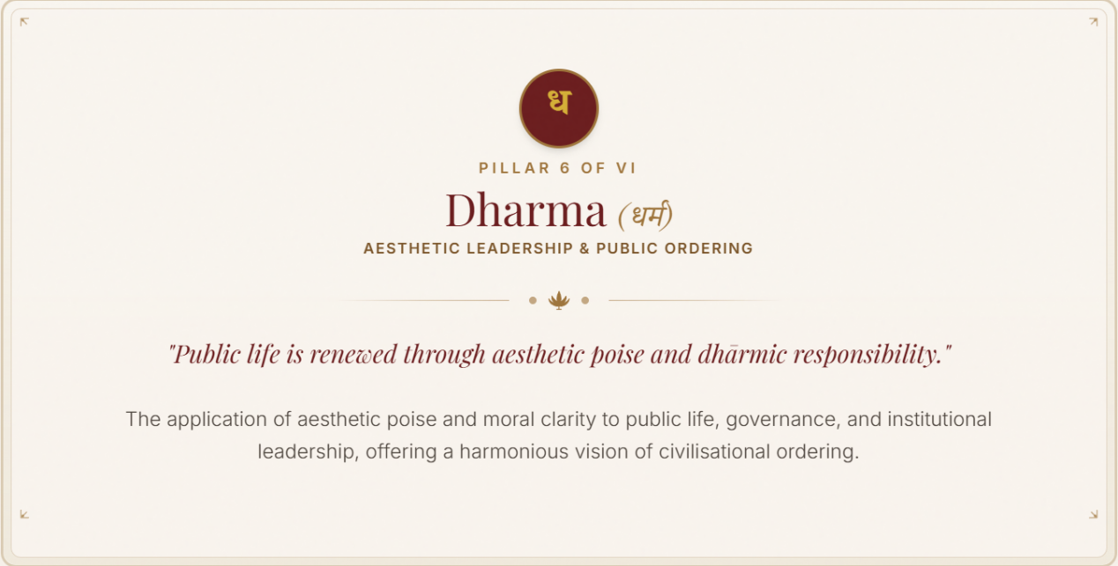
With the following text:
Dharma (धर्म)
AESTHETIC LEADERSHIP & CIVILISATIONAL ORDERING*
“Public life is renewed through aesthetic poise and dhārmic responsibility.”
The extension of aesthetic cultivation into public life, governance, and institutional leadership—bringing poise, responsibility, and discernment to the work of civilisational ordering.

- Our Publications- The thumbnails are too big. Reduce substantially.
- The name and designation below the image of the fire alter may be deleted
- Revise ‘Life Vision’ to ‘Life Vision of the Yajamāna & Yojaka’
- Revise description of NG in the footer to:
Nāṭyaśāstra Gurukulam
A living institution dedicated to the study, practice, and renewal of Nāṭya as a civilisational knowledge system.

ABOUT PAGE

- Our story- The First Sankalpa (The photo caption doesn’t have accompanying photo)
- Our story- Pratishtha Samaroham (use actual photo shared)

PUBLICATIONS PAGE
- Flagship Treatise is the DTHF Paper (enclosed), not the one displayed

PROGRAMMES PAGE
- One of our recent porgrammes, the Nāma • Rūpa • Nāda • Bindu immersion needs to be highlighted (collaterals enclosed)
- One section for Forthcoming programmes:

Reimagining the Sabhā: A Saṃvāda in Nāṭya
27 December 2026 · Chennai
A Margazhi conversation on differentiation, svadharma, and the future of Nāṭya
During Chennai’s Margazhi season, Aatmalaya Academy of Art and Culture, in collaboration with Nāṭyaśāstra Gurukulam, convenes a Saṃvāda on the future of the Sabhā.
The Sabhā was never merely a venue for performance. It was an assembly shaped by aesthetic discernment, shared cultural literacy, the relationship between artist and rasika, and continuity across generations.
Today, however, practitioners with very different artistic purposes, stages of development, audiences, and economic realities increasingly inhabit the same institutional framework. The resulting tensions raise familiar questions of access, opportunity, remuneration, and ‘pay to perform’. Beneath these questions lies a deeper one:
Could the future of the Sabhā lie in differentiation?
At the heart of the enquiry is svadharma—the distinctive orientation, responsibility, and voice of each practitioner.
The conversation will explore three propositions:
I. THE SABHĀ
The future of the Sabhā lies in differentiation.
II. THE PRACTITIONER
The future of the Nāṭya practitioner depends less on securing platforms and more on cultivating one's own assembly.
III. THE PURPOSE
A Sabhā ultimately exists not merely to sustain performance, but to sustain the conditions in which Rasa can arise.
Each proposition will be examined through contrasting voices, followed by moderated exchange. The format is deliberately concise and dialogic: participants will be invited to speak from experience, conviction, and svadharma rather than deliver conventional papers.
The Saṃvāda seeks neither a single answer nor manufactured consensus. It seeks to create an assembly in which different artistic orientations can be heard, questioned, and placed in relation to one another—and to identify propositions that may contribute to the future ecology of Nāṭya.
27 December 2026 | Morning
at Narada Gana Sabha under the auspices of Karthik Fine Arts, Chennai

- ‘JOIN THE JOURNEY: ASSOCIATE WITH US’ can replace the GALLERY PAGE

